CHAPTER 2: Getting into genes
Worksheet 2.3

Mitosis
Student: Class:

True or false
1. Answer ‘true’ or ‘false’ to each of the following statements about mitosis.
(a) Mitosis occurs in the nucleus of a cell. .................................................
(b) Mitosis results in the formation of one new cell. ........................................
(c) Two new and identical cells form as the result of mitosis. .....................................
(d) New cells contain the same number of chromosomes as the original cell. ......................................

Jumbled stages of mitosis
2. The following drawings show the four stages of mitosis.
A B
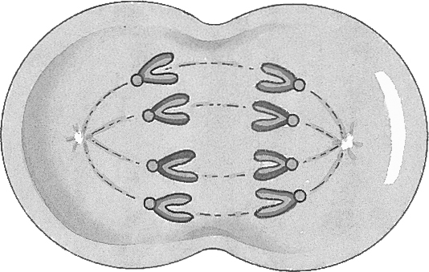 |  | 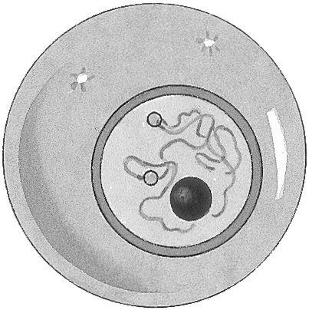

C D
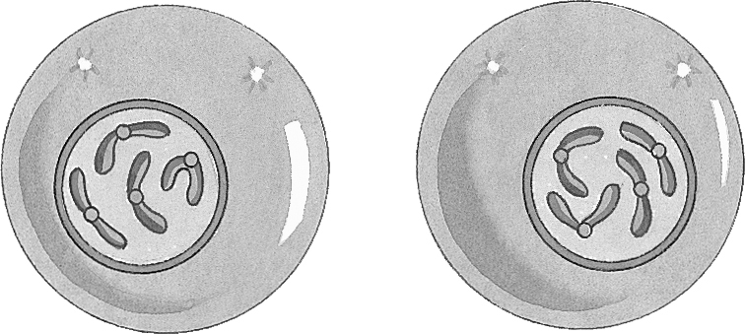 |  | 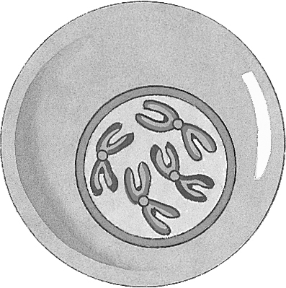
(a) Arrange these stages in the correct sequence using the code letters.

(b) Explain why the chromosomes in diagram D appear as double stranded.

CHAPTER 2: Getting into genes
Worksheet 2.3

Page 2

Replication
3. During mitosis the DNA makes a copy of itself.
(a) Complete the diagram below by inserting the letter of the nitrogen base in the new DNA strand that is forming.
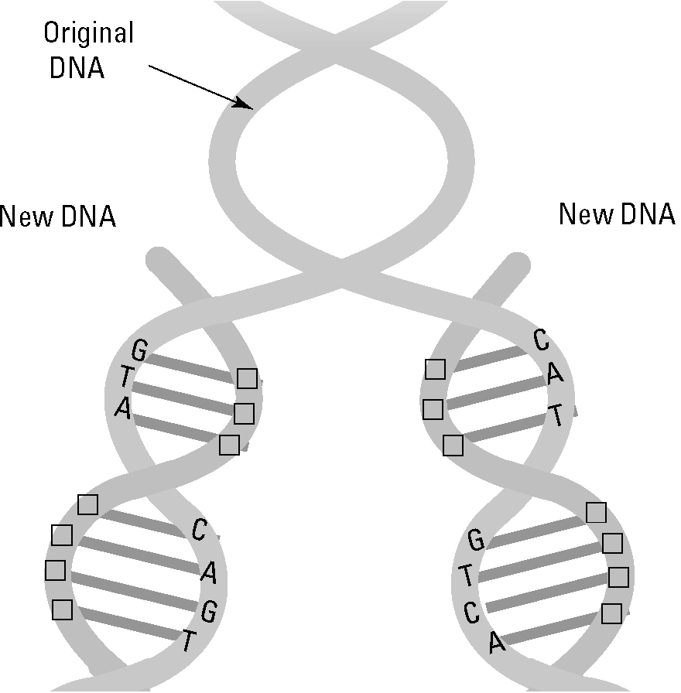
(b) Identify the region of the pea seedling where cells are undergoing mitosis.
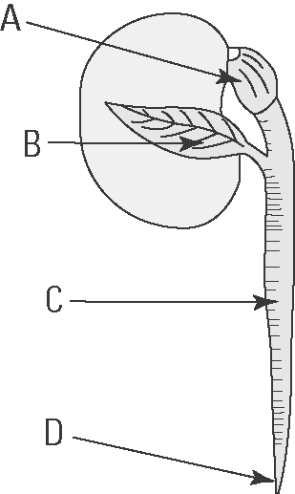
Answer: ..........................

